**Anomaly Detection on Marine Traffic**

**for**

**Future Planning**

MCAST Institute of Information and Communication Technology

Lee Pace

[Lee.pace.a100433@mcast.edu.mt](mailto:Lee.pace.a100433@mcast.edu.mt)

**Abstract**

Marine traffic is increasing as time goes by, so in order to solve future problems like to manage the marine traffic, construction (ex: wind farms, fish farms) or activities like sailing competitions. The project will create a map with Automatic Identification Data (AIS) and will create a history map of all the marine vessel navigation routes and with it can be displayed where the heavy routes are and possibly detect some illegal activities like fishing in protected areas.

Keywords: AIS data, AIS data Visualization

**Hypothesis/Research question**

Can a map be created showing marine traffic, so that with the growth for demand in the marine areas (e.g. offshore wind power plants) require some planning about the heavy marine traffic. With this project future allocation plans in marine about human and temporally activities can be placed in safe areas away from the heavy marine traffic.

1. What dataset is needed, and features are important for the creation of this prototype?
2. What types of techniques can be used for detection and recognition of vessels?
3. What evaluation techniques are needed to benchmark such a prototype?

**I. Introduction**

Various studies have pointed out the importance of AIS (Automatic Identification System) (Jiacai, P., Qingshan, J., Jinxing, H. and Zheping, S., 2012; Fiorini, M., Capata, A. and Bloisi, D.D., 2016; Perez, H.M., Chang, R., Billings, R. and Kosub, T.L., 2009; Olindersson, F. and Janson, C.E., 2015.; Mustaffa, M., Ahmat, N.H. and Ahmad, S., 2015.) and of Anomaly Detection (Mascaro, S., Nicholso, A.E. and Korb, K.B., 2014) for vessel traffic visualization. Since 2002 all passenger and large sea vessels are required to carry AIS onboard. With this system ships can make themselves visible to each other. This aids in collision avoidance and in taking records of ship maneuverability history (Mustaffa, M., Ahmat, N.H. and Ahmad, S., 2015.). With “AIS data” (Fiorini, M., Capata, A. and Bloisi, D.D., 2016) datasets are created so they can be used in various studies like visualizing the path history of the vessels.

**II. Automatic Identification System (AIS)**

In case of Mustaffa, M., Ahmat, N.H. and Ahmad, S., (2015) they used several equipment like AIS receiver and antenna, AIS decoder and AIS analyzer. This was done so they can collect the AIS data for port Klang. The data was all recorded in a CSV file which later was analyzed using spreadsheets program.

Where incase of Fiorini, M., Capata, A. and Bloisi, D.D., (2016) they obtained the AIS raw data and a database management system (DBMS) was used to handle the millions of records.

In the AIS data contains all the information of the ship that was transmitted from the AIS transmitter. This data contains all the actions of the vessel made during the route like destination, speed, longitude and latitude which is transmitted every 2 to 10. Moreover every 6 minutes more information is sent like ship name, identification number, type of vessel, etc. Because of this the data must be filtered to key indexes so later “map construction and interactive map visualization” (Fiorini, M., Capata, A. and Bloisi, D.D., 2016) can be created.

In case of Jiacai, P., Qingshan, J., Jinxing, H. and Zheping, S., (2012) they created “AIS Data Visualization Model” with combines three features which are rate of encounter, rate of turn and speed acceleration which later is visualized on “Electronic Chart Display” and “Information System (ECDIS)”. This model uses various algorithms to process the data in each feature so later the longitude and latitude are found of visualized on a map.

**III. Anomaly Detection**

According to Mascaro, S., Nicholso, A.E. and Korb, K.B., (2014) models from Gaussian mixture models, support vector machines and neural networks have a disadvantage which they do not provide a transparent model for the human user.

At Bayesian Network (BN) anomaly detection has 2 advantages over the others which is that they are easily understood by people who are not BN specialist and they allow for the straightforward incorporation of expert knowledge.

**Methodology**

First things first the AIS data need to be obtained, which will be going with obtaining a data set from a company instead of collecting it ourselves. The data set will be provided by Marine Cadastre(Marine Cadastre, n.d.). After the data set will be viewed and plotted with python on a map

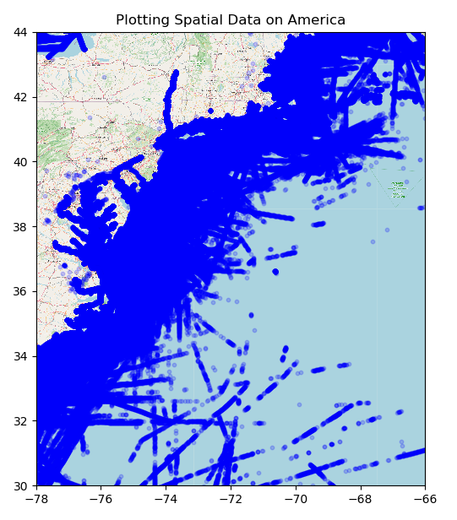

After a python library called PyOD will be used for anomaly detection.

**Evaluation**

The data sets were successfully plotted on a map although the map is a bit misaligned because the website that the map was taken from was saving incorrectly or some error even if the user inputs the coordinates himself.

**Conclusion**

The project has potential although its incomplete and can work to be used to plan for future planning